**Noisy channels**

|  |  |
| --- | --- |
| Subject | Noisy channels |
| S1 | 5, 9, 18, 22, 26, 28, 33 |
| S2 | Exclude – too many noisy channels |
| S3 | Exclude – too many noisy channels |
| S4 | 24 |
| S5 | 5, 8, 10, 12, 15, 33, 40 |
| S6 | 30, 43 |
| S7 | 1, 13, 23, 37 |
| S8 | 40 |
| S9 | 12, 20, 28, |
| S10 | Exclude – too many noisy channels |
| S11 |  |
| S12 | 5, 6, 9, 22, 25, 34, 36 |
| S13 | Exclude – left handed |
| S14 | Exclude – left handed |
| S15 | 4, 7, 18, 20, 27, 31 |
| S16 | 4, 19, 21, 22, 23, 24, 28, 32, 33, 37 (too many?) |
| S17 | 22, 28, 38, 42, 43 |
| S18 | 10, 18, 21, 24, 30 |

**Noisy channels with excluded data**

|  |  |
| --- | --- |
| Subject | Noisy channels |
| S1 | 5, 9, 18, 22, 26, 28, 33 |
| S4 | 24 |
| S5 | 5, 8, 10, 12, 15, 33, 40 |
| S6 | 30, 43 |
| S7 | 1, 13, 23, 37 |
| S8 | 40 |
| S9 | 12, 20, 28, |
| S11 |  |
| S12 | 5, 6, 9, 22, 25, 34, 36 |
| S15 | 4, 7, 18, 20, 27, 31 |
| S16 | 4, 19, 21, 22, 23, 24, 28, 32, 33, 37 (too many noisy?) |
| S17 | 22, 28, 38, 42, 43 |
| S18 | 10, 18, 21, 24, 30 |

A total of 13 subjects.

**S09 brain template with optodes in good positions to get an idea of where the above stated channels are on the brain.**

**Left:**

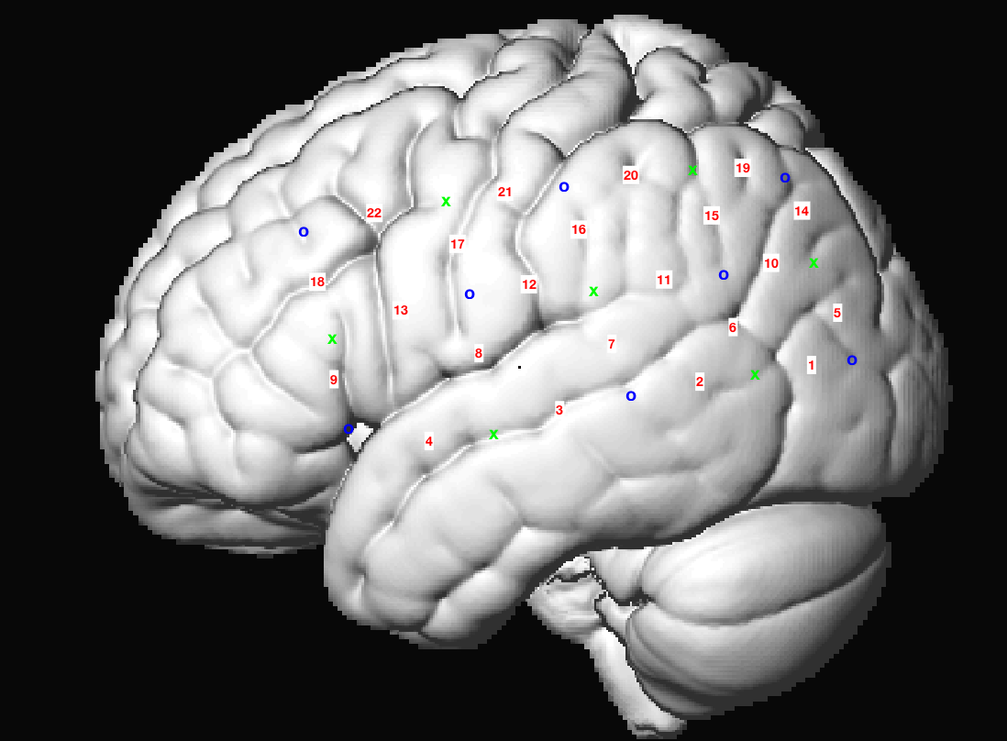

**Right:**

